

Zain NetCell
Technical Documentation
IT Operations – Support


Version: 1.0
Date: JAN 25, 2024

Contents
1 Document Overview 6
1.1 Document Purpose 6
1.2 What is NetCell System? 6
1.3 Why NetCell from Leading point? 6
1.4 Document References 6
1.5 Document Keys 7
2 Mobile Network Technologies 8
2.1 2G (2nd Generation): 8
2.2 3G (3rd Generation): 8
2.3 4G (4th Generation): 8
2.4 5G (5th Generation): 9
3 Zain Network Technologies 10
3.1 Nokia technologies: 10
3.2 Huawei technologies: 10
3.3 MIX (Huawei and Nokia) technologies: 10
4 System Modules 11
4.1 Performance Management (PM) 11
4.2 Configuration Management (CM) 11
4.3 Fault Management (FM) 11
4.4 SON (Self Organization Network) Reports 11
5 System Layers 12
5.1 Infrastructure Layer: 12
5.2 Database Layer: 12
5.2.1 PM Database. 13
5.3 Integration Layer (Backend Processes-Jobs) 15
5.3.1 Huawei backend Process. 16
5.3.2 Nokia backend Process. 18
5.3.3 Mix backend Process. 20
5.4 Presentation Layer (UI): 23
5.4.1 How to generate report\KPI from the system? 23
6 Common issues : 26
6.1 Missing period in Huawei database. 26
6.2 Missing period in Nokia database. 28
6.3 Missing period in Mix database. 31
6.4 The data does not match between Mix and other Vendors (Check Accuracy data service). 32

Revisions
Date | Version | Issuer | Remarks
06/02/2024 | 1.0 | Zaid Bani Khaled | Create document
11/11/2024 | 1.1 | Zaid Bani Khaled | Update servers Info
Approvals
Date | Title | Name | Department | Signature

Document Overview

Document Purpose
This document contains a technical description of the Zain NetCell Modules and all related services that may need support from the operation department.

What is NetCell System?
NetCell is a single-point platform through which a telecom observes and diagnoses the network performance and identifies areas of improvement through real-time, automated, and customized dashboards about whatever aspect and perspective of the network status.

Why NetCell from Leading point?
- With NetCell, there is no need to aggregate fragmented data about the network in external sheets or hassle around the many systems to collect scattered data to form meaningful information for action. NetCell customizes dashboards and makes any data of need available in its place and time ready for action with a few clicks.
- Furthermore, NetCell is a web-based application hosted on the cloud and mobile-friendly. With easy clicks, it empowers experts with portability wherever and whenever they need any data about the network, backing the effort in real-time.
- NetCell integrates with digital telecom assets to be part of workflows, dashboards, and enterprise services.
- NetCell integrates with digital telecom assets to be part of workflows, dashboards, and enterprise services.

Document References
- https://www.leading-point.com/netcell.
- Zain NetCell Servers.
- Handover sessions.

Document Keys

Item | Description
Cell | a single base station in a cellular network covers a specific geographic area specific geographic area covered by a single base station in a cellular network, allowing for efficient and seamless mobile communication.
cm | Configuration Management.
FM | Fault Management.
PM | Performance Management.
SON | Self-Organization Network.
2G, 3g, 4G, 5G | The generations of wireless data communication for mobile carriers.

Mobile Network Technologies
Mobile network technologies refer to the various generations of cellular communication systems that enable wireless communication and data transfer between mobile devices, such as smartphones, tablets, and other mobile gadgets. Here are the key mobile network technologies:

2G (2nd Generation):
  - Technology: 2G refers to the second generation of mobile networks.
  - Data Transfer: Primarily focused on voice communication with some limited data capabilities (text messages, basic internet browsing).
  - Speeds: Relatively low data transfer rates, typically in the range of tens of kilobits per second (Kbps).
  - Standards: Common standards include GSM (Global System for Mobile Communications) and CDMA (Code Division Multiple Access).

3G (3rd Generation):
  - Technology: 3G is the third generation of mobile networks.
  - Data Transfer: Significant improvement in data capabilities compared to 2G, supporting higher data transfer rates.
  - Speeds: Data rates in the range of several hundred kilobits per second (Kbps) to a few megabits per second (Mbps).
  - Features: Enhanced capabilities for multimedia services, video calls, and faster internet browsing.
  - Standards: UMTS (Universal Mobile Telecommunications System) is a common standard for 3G.

4G (4th Generation):
  - Technology: 4G is the fourth generation of mobile networks.
  - Data Transfer: Designed to provide high-speed wireless communication and significantly improved data transfer rates compared to 3G.
  - Speeds: Offers data rates in the range of tens of megabits per second (Mbps) to hundreds of Mbps.
  - Features: Enhanced support for mobile broadband, streaming multimedia, and improved quality of service.
  - Standards: LTE (Long-Term Evolution) and WiMAX are common 4G technologies.

5G (5th Generation):
  - Technology: 5G is the fifth generation of mobile networks.
  - Data Transfer: Aims to provide even higher data transfer rates, lower latency, and improved reliability compared to 4G.
  - Speeds: Offers data rates in the range of multiple gigabits per second (Gbps).
  - Features: Designed to support a massive number of connected devices simultaneously, enable low-latency applications like augmented reality (AR) and virtual reality (VR), and enhance overall network performance.
  - Standards: 5G NR (New Radio) is a key standard for 5G networks.

Zain Network Technologies

NetCell is a system that has been developed to extract data from Zain's network Elements from two types of mobile network service providers: Nokia and Huawei. A third type has been added to integrate data from both networks into the same database that is called MIX Database. This provides the capability to generate unified reports and KPIs for a comprehensive analysis of the network performance. The following points describe all technologies and their sub types for each cell generation.

Nokia technologies:
- 2G: BTS, CS, TRX.
- 3G: LCG, RNC, RSGS, WCEL.
- 4G: LNBTS, LNCEL.
- 5G: EQM, MNL, NRBTS, NRCELL.

Huawei technologies:
- 2G: CELL, GCELL.
- 3G: UCELL.
- 4G: CELL.

MIX (Huawei and Nokia) technologies:
- 2G: MIXCELL.
- 3G: MIXCELL.
- 4G: MIXCELL.

System Modules
The Zain NetCell system comprises four main modules:

Performance Management (PM)
This module is the main and the most important module in the system, it enables extracting a set of KPIs based on data that has already been collected from the network. This is done to understand the overall status of the network and identify areas for improvement. This Module covers all technologies (Nokia, Huawei, and MIX)

Configuration Management (CM)
This module is responsible for viewing the current configuration and the configuration history of all network elements (Cell, Site, controller).

Fault Management (FM)
This module is responsible for detecting problems to keep connectivity, applications, and services running at an optimum level, provide fault tolerance, and minimize downtime.

SON (Self Organization Network) Reports
This module encompasses different aspects of network operation. Their implementation can considerably alleviate operational complexity and speed up processes.

System Layers

Infrastructure Layer:
This layer deals with the infrastructure and communication between different components. It includes servers and networking components.

The following table describes current Environment:
Server Description | Server IP | Username | Password
Backup server | 192.168.7.38 | TEMSDB_DL380\Leadinguser | :a(sqMF2gz
Old Nokia server | 192.168.7.39 | TEMSPM_DL580\Leadinguser | Zain@1234
Huawei server | 192.168.7.201 | Leading point | LP_#$79
Mix server | 192.168.7.202 | Leading point | LP_#$79

Database Layer:
This layer manages the storage and retrieval of data, it includes databases for all system components. The database layer is responsible for handling data-related operations like querying, inserting, updating, and deleting records.

The following table describes All Database related to Zain NetCell:
Database Name | Server IP | Technology | System module
ran_performance_setup | 192.168.7.201 | All | PM
ran_performance_data_nokia | 192.168.7.201 | NOKIA | PM
ran_fault_data_huawei | 192.168.7.201 | HUAWEI | FM
ran_performance_data_huawei | 192.168.7.201 | HUAWEI | PM
ran_performance_data_mix | 192.168.7.202 | MIX | PM
ran_configuration_data_huawei | 192.168.7.202 | HUAWEI | CM
ran_configuration_setup | 192.168.7.202 | HUAWEI | CM

PM Database.
- Huawei PM tables based on Time period and Object:

Cell Gen | Objects | Time period
2g | Cell, Cluster, Control, Governorate, Region, subdistrict | Hourly, Daily, Weekly, Monthly
3g | Cell, Band, Cluster, Control, Governorate, Region, Region Band, subdistrict | Hourly, Daily, Weekly, Monthly
4g | Cell, Cluster, Cluster Band, ClusterXdd, Control, Governorate, Region, Region Band, RegionXdd, Subdistrict, Subdistrict Band, SubdistrictXdd, Xdd | Hourly, Daily, Weekly, Monthly

- Nokia PM tables based on Time period and Object:

Cell Gen | Objects | Time period
2g | Cell, Cluster, Control, Governorate, Region, subdistrict | Raw, Hourly, Daily, Weekly, Monthly
3g | Cell, Band, Cluster, Control, Governorate, Region, Region Band, subdistrict | Raw, Hourly, Daily, Weekly, Monthly
4g | Cell, Cluster, Cluster Band, ClusterXdd, Control, Governorate, Region, Region Band, RegionXdd, Subdistrict, Subdistrict Band, SubdistrictXdd, Xdd | Raw, Hourly, Daily, Weekly, Monthly
5g | Cell, Cluster, Cluster Band, ClusterXdd, Control, Governorate, Region, Region Band, RegionXdd, Subdistrict, Subdistrict Band, SubdistrictXdd, Xdd | Raw, Hourly, Daily, Weekly, Monthly

- MIX PM tables based on Time period and Object:

Cell Gen | Objects | Time period
2g | Cell, Cluster, Control, Governorate, Region, Site, subdistrict | Hourly, Daily, Weekly, Monthly
3g | Cell, Band, Cluster, Control, Governorate, Region, Region Band, subdistrict | Hourly, Daily, Weekly, Monthly
4g | Cell, Cluster, Cluster Band, ClusterXdd, Control, Governorate, Region, Region Band, RegionXdd, Site, Subdistrict, Subdistrict Band, SubdistrictXdd, Xdd | Hourly, Daily, Weekly, Monthly

- Important notes
- Raw data is referred to as the data that comes every 15 minutes from the network.
- Network elements are defined in the tables that end with *_setup.
- Aggregated tables for Time period have a name Like (2g_cell_monthly, 3g_cell_daily, 4g_cell_weekly ...)
- Aggregated Tables for both Time period and Object have a name Like (4g_cell_daily_cluster,3g_cell_hourly_region ….)

Integration Layer (Backend Processes-Jobs)

The integration layer plays a crucial role in connecting different components, modules, or external services within the application architecture. The integration layer facilitates communication and data exchange between various parts of the application, ensuring seamless operation and interoperability. In Net-Cell system there are many integration processes/jobs working in the background to handle the integration between all system parts. Below is an explanation of all these processes in general.

- FTP Sync: This process is responsible for copying network data files from FTP servers into local paths. After completing the file copying process, this service creates a text file named ‘done’.
- Parser: This service is responsible for converting the data files that comes from FTP servers into Readable CSV as following:
      - Read Each 10 files as a one batch.
      - Convert these 10 files into one readable CSV.
      - Move CSV file to Database Loader Repository paths.
      - This process stops after reading the text file named 'done'.
- Database Loader: This process is responsible for uploading CSV files to the database.

- Data aggregator: This process is responsible for aggregating network data from main table that was uploaded from Loader into many tables based on period e.g. (daily, weekly, Monthly) or Object and Time period (hourly control, daily region, monthly clusters ...).

- Reaggregation: this process responsible for reaggregate data in case something goes wrong or there are missing periods in the aggregated data, this service can be run based on some options (period type, Target Tables Type and technology)

- Notifications: this service notifies the responsible users about missing periods in the database for all technologies.
- Check Mix Accuracy: this service checks the accuracy between MIX database and other Vendors (Nokia and Huawei).

Huawei backend Process.
Huawei backend services have been deployed on this server 192.168.7.201 and all services related to Huawei will be described in the below tables:
- Huawei FTP sync: this service repeats every hour to copy Huawei files from FTP server to Parser’s repository folder.
Service name | Service Path | Triggers
FTP_SYNC | D:\LeadingPoint\Programs\Prod\Huawei\FTPSync | Every 1 hour

- Huawei Parser: this service repeats every hour to convert Huawei files into Readable CSV files then move it to Loader’s repository folder.
Service name | Service Path | Triggers
2G Parser | D:\LeadingPoint\Programs\Prod\Huawei\FilesParser\2G | Every 1 hour
3G parser | D:\LeadingPoint\Programs\Prod\Huawei\FilesParser\3G | Every 1 hour
4G parser | D:\LeadingPoint\Programs\Prod\Huawei\FilesParser\4G | Every 1 hour

- Huawei Loader: this service repeats every hour to load the CSV files from Loader’s repository folder to Huawei database ‘Ran_performance_Huawei’.
Service name | Service Path | Triggers
Loader | D:\LeadingPoint\Programs\Prod\Huawei\FilesLoader | Every 1 hour

- Aggregation services: This service works to aggregate data according to the time period and object, then saving it in its own table as described below:
Service name | Service Path | Description and Trigger
Hourly aggregation | D:\LeadingPoint\Programs\Prod\Huawei\LP.DynamicDataAggregator\Huawei_Mix_Aggregation_Replacement | This service works every hour to aggregate the data from main hourly table to other hourly objects table for the data that was inserted before 2 hours
Daily aggregation | D:\LeadingPoint\Programs\Prod\Huawei\LP.DynamicDataAggregator\Aggregator_daily | This service works every day at 4:00 AM to aggregate the data for the previous day for all objects
Weekly aggregation | D:\LeadingPoint\Programs\Prod\Huawei\LP.DynamicDataAggregator\Aggregator_weekly | This service works every week on Sunday at 5:00 AM to aggregate the data for the previous week for all objects
Monthly aggregator | D:\LeadingPoint\Programs\Prod\Huawei\LP.DynamicDataAggregator\Aggregator_mothly | This service works every month on day 1 at 5:00 AM to aggregate the data for the previous month for all objects

- Create partitions: this service works on creating all tables partitions on Huawei database ‘Ran_performance_Huawei’ based on partitioning described in Appendix 02.
Service name | Service Path | Trigger
Create partition | D:\LeadingPoint\Programs\Prod\Huawei\LP.Zain.Partitioning | Every day at 12:10AM

- Tagging Service: it is responsible of Add, update, and disable Huawei tags on Huawei setups tables.
Service name | Service Path | Trigger
Tagging | D:\LeadingPoint\Programs\Prod\Huawei\Tagging | Every day at 6:00AM  Every day at 6:00PM

- Fault service: this service works as parser and loader services. It uploads error logs files that come from FTP servers to Huawei fault database ‘ran_fault_data_huawei’ after converting it to CSV readable files.
That helps the system users to generate reports and KPIs to determine network errors and resolve them.
Service name | Service Path | Trigger
Fault | D:\LeadingPoint\Programs\Prod\Fault\FaultFilesProcessor | Every day at 3:00 AM

Nokia backend Process.
Nokia backend services have been deployed on this server 192.168.7.39 and all services related to Nokia will be described in this section:
- Nokia FTP sync: this service repeats every 15 minutes to copy Nokia files from FTP server to Parser’s repository folder, this data calls Raw data.
Service name | Service Path | Triggers
FTP SYNC | D:\LeadingPoint\Programs\Prod\Nokia\FTPSync | Every 15 minutes
- Nokia Parser: this service repeats every hour to convert Nokia files into Readable CSV files then move it to Loader’s repository folder.
** 4G parser new is duplicated parser of 4g parser, it’s created due to the huge number of raw files comes from ftp sync for this technology and we need to converting it into CSV in 15 minutes before next run of FTP sync.
Service name | Service Path | Triggers
2G Parser | D:\LeadingPoint\Programs\Prod\Nokia\FilesParser\2G | Every 15 minutes
3G parser | D:\LeadingPoint\Programs\Prod\Nokia\FilesParser\3G | Every 15 minutes
4G parser | D:\LeadingPoint\Programs\Prod\Nokia\FilesParser\4G | Every 15 minutes
4G parser New | D:\LeadingPoint\Programs\Prod\Nokia\FilesParser\4G_new | Every 30 minutes
5G parser | D:\LeadingPoint\Programs\Prod\Nokia\FilesParser\5G | Every 15 minutes

- Nokia Loader: this service repeats every 15 minutes to load the CSV files from Loader’s repository folder to Nokia database ‘Ran_performance_Nokia’.
Nokia uploader works to upload the data on the main Raw table depending on the cell generation and technology.
Service name | Service Path | Triggers
Loader | D:\LeadingPoint\Programs\Prod\Nokia\FilesLoader | Every 15 minutes

- Aggregation services: This service works to aggregate data according to the time period and object, then saving it in its own table as described below:
Service name | Service Path | Description and Trigger
Raw aggregation | D:\LeadingPoint\Programs\Prod\Nokia\DynamicDataAggregator\Aggregator_raw | This service works every hour to aggregate the data from main raw table to other hourly objects table for the data that was inserted before 2 hours
Daily aggregation | D:\LeadingPoint\Programs\Prod\Nokia\DynamicDataAggregator\Aggregator_daily_ext | This service works every day at 4:00 AM to aggregate the data for the previous day for all objects
Weekly aggregation | D:\LeadingPoint\Programs\Prod\Nokia\DynamicDataAggregator\Aggregator_weekly_all | This service works Every week on Sunday at 4:30 AM to aggregate the data for the previous week for all objects
Monthly aggregator | D:\LeadingPoint\Programs\Prod\Nokia\DynamicDataAggregator\Aggregator_monthly_all | This service works every month on day 1 at 5:00 AM to aggregate the data for the last month for all objects
- Create partitions: this service works on creating all tables’ partitions on Nokia database ‘Ran_performance_Nokia’ based on partitioning rules described in Appendix 02.
Service name | Service Path | Trigger
Create partition | D:\LeadingPoint\Programs\Prod\Nokia\LP.Zain.Partitioning | Every day at 12:30 Am

- FTP_SYNC_CELL_NAME: it is responsible of get updated Cell name from Nokia FTP servers every hour.
Service name | Service Path | Trigger
FTP_SYNC_CELL_NAME | D:\LeadingPoint\Programs\Prod\Nokia\FTPSync - Nokia - Cell Names | Every 1 hour

- Nokia CellName Agg Service: this service works as parser and loader services. It uses the files that come from FTP_SYNC_CELL_NAME to updates Cell Info on Nokia and Mix Setup database (ran_performance_setup, ran_performance_data_mix).
Service name | Service Path | Trigger
Nokia_CellNameAgg_Service | D:\LeadingPoint\Programs\Prod\Nokia\Nokia_CellName_Agg_Service_With_Mix | Every 1 hour

- Reaggregation: it’s a web service use to reaggregate Nokia data from main table to other tables based on some options as below.
Service name | Service info | Service options
Reaggregation | Service Body: {  "PeriodType": "hourly",  "TargetTablesType": "all",  "Technology": "3g",  "PeriodStartDateTime":"2024-01-29 09:00:00 ",  "PeriodEndDateTime": "2024-01-29 13:00:00",  "DeleteBeforeAggregate": true  }  ……………..  Service link: http://ipaddress:port/LP.API.ReAggregation/api/aggregator/reaggregatedata | 1. Period Type: hourly, daily, weekly, and monthly.  2. Technology: 2g, 3g, 4g.  3. Target Tables Type: cluster, region, …etc.
- Nokia Notifications: to checking missing period in Nokia database then inform system users by email about the missing.
Service name | Service Path | Trigger
Create partition | D:\LeadingPoint\Programs\HuaweiProd\Huawei\LP.Zain.DataReAggregation\LP.Zain.DataReAggregation.Notification\bin\NokiaNotification | Every 1 hour
- Create Files: it’s a batch file to recreate loader and parser paths after restarting the machine as it’s created on RAM storage.
Service name | Service Path | Trigger
Create Files | D:\LeadingPoint\Support | At startup

Mix backend Process.
Mix backend services have been deployed on this server 192.168.7.201 and all services related to Mix will be described in this section:

- Mix Loader: this service is responsible for loading the data from Loader’s repository folder to MIX database ‘Ran_performance_MIX’.
Service name | Service Path | Triggers | Loader folder
Huawei | D:\LeadingPoint\Programs\Prod\Mix\Mix_Loader_Huawei | Every 1 hour | D:\LeadingPoint\Programs\Prod\Mix\Mix_Loader_Huawei\LoadData
Nokia | D:\LeadingPoint\Programs\Prod\Mix\Mix_Loader_Nokia | Every 1 hour | D:\LeadingPoint\Programs\Prod\Mix\Mix_Loader_Nokia\LoadData

- Aggregation services: This service works to aggregate data according to the time period and object, then saving it in its own table as described below:
Service name | Service Path | Description and Trigger
Hourly aggregation | D:\LeadingPoint\Programs\Prod\Mix\Hourly_Data_Aggregator_Mix | This service works every hour to aggregate the data from main hourly table to other hourly objects table for the data that was inserted before 2 hours
Daily aggregation | D:\LeadingPoint\Programs\Prod\Mix\Daily_Data_Aggregator_Mix | This service works every day at 4:00 AM to aggregate the data for the previous day for all objects
Weekly aggregation | D:\LeadingPoint\Programs\Prod\Mix\Weekly_Data_Aggregator_Mix | This service works every Sunday at 4:30 AM to aggregate the data for the previous week for all objects
Monthly aggregator | D:\LeadingPoint\Programs\Prod\Mix\Monthly_Data_Aggregator_Mix | This service works every month on day 1 at 5:00 AM to aggregate the data for the previous month for all objects

- Tagging Service: it is responsible of Add, update, and disable Huawei tags in Mix database setups tables.
Service name | Service Path | Trigger
Tagging | D:\LeadingPoint\Programs\Prod\Mix\MixTagging | Every day at 6:00AM  Every day at 6:00PM

- Mix Notifications:
      - Check Accuracy Notification: send email Notification to system users after Finding differences between mix and other databases (Nokia and Huawei).
      - send email Notification to system users after finding missing period in mix database.

Service name | Service Path | Triggers
Check Mix Accuracy Hourly with Email 2G | D:\LeadingPoint\Programs\Prod\Mix\Check_Mix_Accuracy_Hourly_WithEmail_2g | Every 1 hour
Check Mix Accuracy Hourly with Email 3G | D:\LeadingPoint\Programs\Prod\Mix\Check_Mix_Accuracy_Hourly_WithEmail_3g | Every 1 hour
Check Mix Accuracy Hourly with Email 4G | D:\LeadingPoint\Programs\Prod\Mix\Check_Mix_Accuracy_Hourly_WithEmail_4g | Every 1 hour
MixNotifications | D:\LeadingPoint\Programs\HuaweiProd\Huawei\LP.Zain.DataReAggregation\LP.Zain.DataReAggregation.Notification\bin\MixNotification | Every 1 hour

Presentation Layer (UI):
This layer is responsible for presenting the user interface and handling user interactions, it includes all system modules (PM, CM, FM, and SON report). The users who are granted to access the system can export reports, KPIs, and charts according to multiple inputs including (date, Time, and network elements ... etc.).

How to generate report\KPI from the system?
- Open web browser, then go to this link ‘http://192.168.7.38:333/’.
- From the left side menu choose the operation type.
- From Operation type select RAN->PM->View for reports or RAN->PM->KPI Builder for KPIs, as shown in below screenshot.
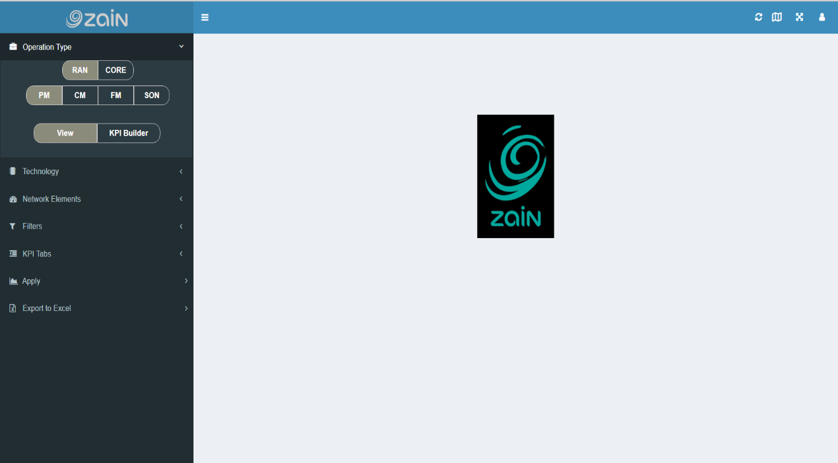

- From Technology sub menu select Vendor and cell generation as shown below.
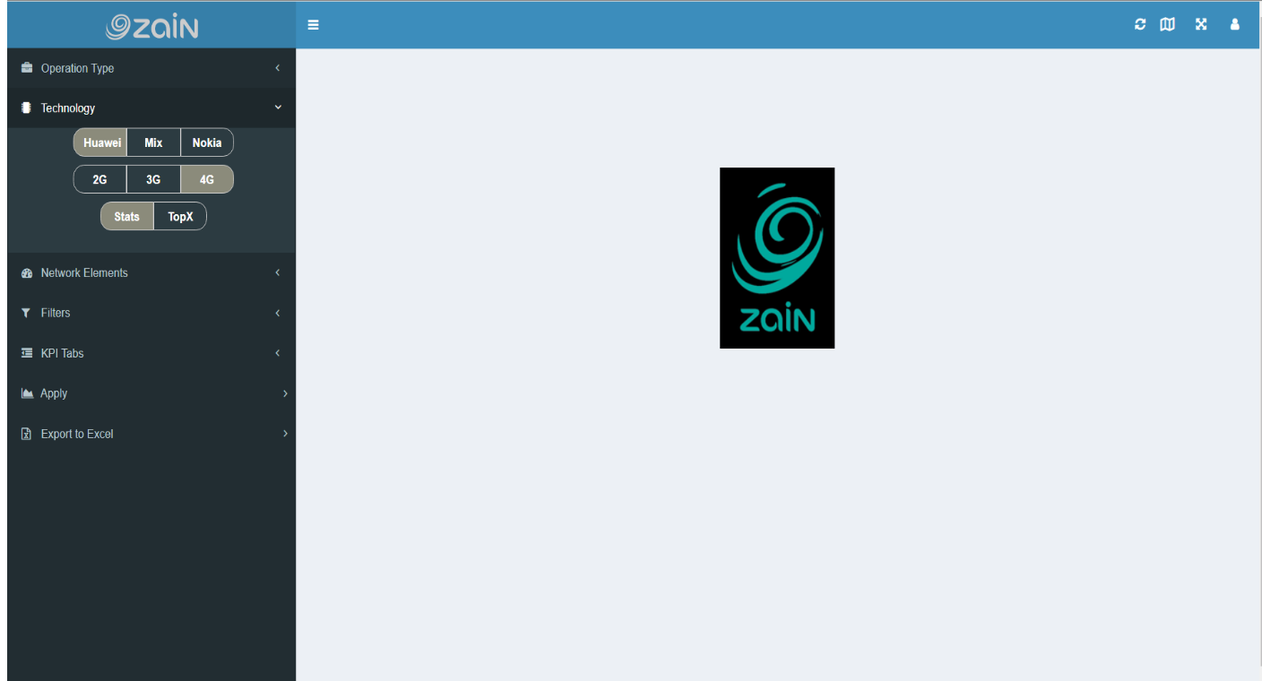
- From Network Elements sub menu select the Target type from drop down list as well as you can search by element name by typing part of the element name in Search tree field as shown in below screenshot.
- Select the entire tree or elements needed to generate its report/KPI for them.
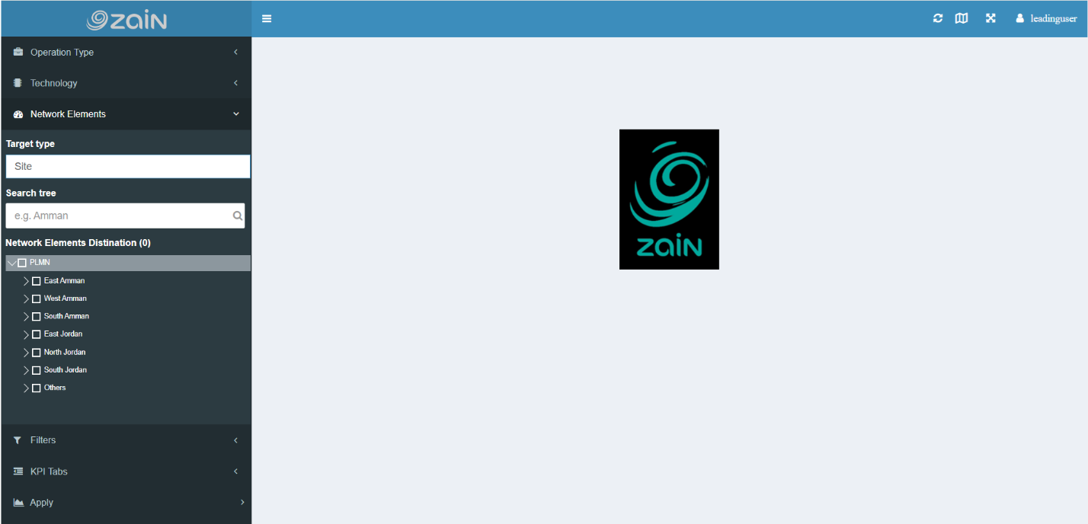

- From Filters sub menu you can filter the data according to the date of this data through two options:
- The list of Predefined Time such as (last hour, Today, Last week, etc.…)
- Manual start and end time this option allows you to select any period of time to generate a report.
      - The below screenshot shows the filters sub menu.
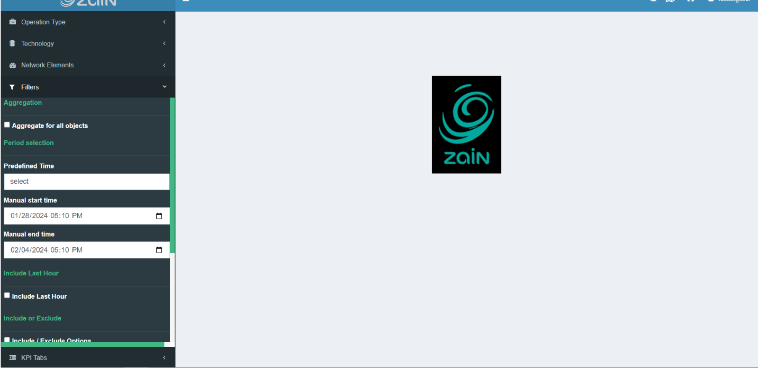

- From KPI Tabs sub menu you can choose one, multi or all available KPI as shown on below screenshots.
- To generate the report/KPI you just need to press Apply after all as shown below.
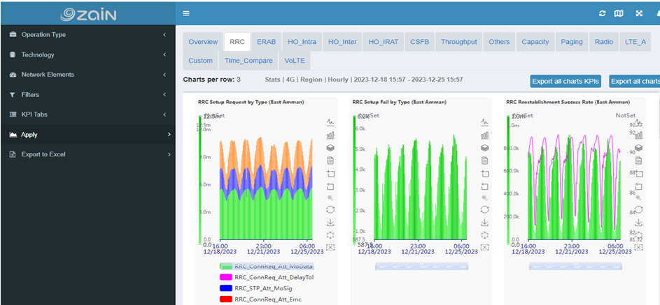

Common issues :

Missing period in Huawei database.
- Hourly data
How to Investigate the issue?
- Check the parser repo folder if all files for this period were converted and moved to loader.
- Check loader repo folder for this period if all files have been uploaded to database.
- Check ftp sync logs if there is any issue with syncing files.
- Check other logs (Parser, loader)
Expected Solution:
- If the issue originated from the loader, simply run it.
- If the issue is related to the parser, check the logs, and restart it.
- If the issue is associated with FTP sync, redownload the files using the support tool, and then move these files to the parser repository folder.
- Run Parser.
- Run Loader once the parser is completed.
- Reaggregate the data for this period if needed.
- Reaggregate daily data for this period if needed.
Example of this issue:
We missed the 4g data for this period H 9 on 10-01-2024.
Expected Solution:
- Download the files using the support tool as shown below.

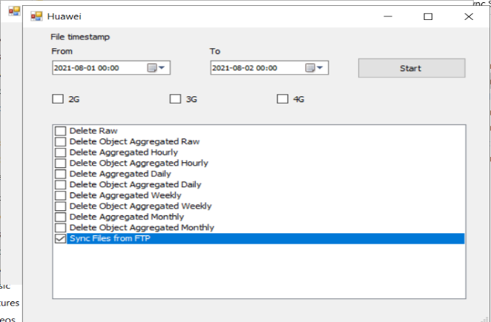
- Run Parser.
- Run Loader once the parser is completed.
- Reaggregate Huawei data from Api as below parameters:
Web service Link: http://192.168.7.38:333/LP.API.ReAggregation/api/aggregator/reaggregatedata
Web service Body :
{
"PeriodType": "Hourly",
"TargetTablesType": "all",
"Technology": "4g",
"PeriodStartDateTime":"2024-01-10 08:00:00 ",
"PeriodEndDateTime": "2024-01-10 09:00:00",
"DeleteBeforeAggregate": true
}
- We need to reaggregate Mix data from Api as below parameters:
Web service Link: http://192.168.7.38:333/LP.API.ReAggregationMix/api/aggregator/reaggregatedata
Web service Body :
{
"PeriodType": "Hourly",
"TargetTablesType": "all",
"Technology": "4g",
"PeriodStartDateTime":"2024-01-10 08:00:00 ",
"PeriodEndDateTime": "2024-01-10 09:00:00",
"DeleteBeforeAggregate": true
}

- Daily data:
Investigate the issue:
Check Logs for Huawei Daily Aggregation Service to identify the error.
Expected solution:
Reaggregate the data of the missed period for Huawei and mix database using reaggregation web services ‘API’.
Example:
We missed the 4g data for this period 07-01-2024 to 09-02-2024.
Expected Solution:
- Reaggregation Huawei data from Api as below parameters.
Web service Link : http://192.168.7.38:333/LP.API.ReAggregation/api/aggregator/reaggregatedata
Web service Body :
{
"PeriodType": "Daily",
"TargetTablesType": "all",
"Technology": "4g",
"PeriodStartDateTime":"2024-02-07 00:00:00 ",
"PeriodEndDateTime": "2024-02-10 00:00:00",
"DeleteBeforeAggregate": true
}
- Reaggregation Mix data from Api as below parameters.
Web service Link : http://192.168.7.38:333/LP.API.ReAggregationMix /api/aggregator/reaggregatedata
Web service Body :
{
"PeriodType": "Daily",
"TargetTablesType": "all",
"Technology": "4g",
"PeriodStartDateTime":"2024-02-07 00:00:00 ",
"PeriodEndDateTime": "2024-02-10 00:00:00",
"DeleteBeforeAggregate": true
}

- Weekly data.
Investigate the issue:
Check Logs for Huawei weekly Aggregation Service to identify the error.
Expected solution:
Reaggregate the data of the missed period for both Huawei and Mix database using reaggregation web services ‘API’.

- Monthly data
Investigate the issue:
Check Logs for Huawei monthly Aggregation Service to identify the error.
Expected solution:
Reaggregate the data of the missed period for both Huawei and Mix database using reaggregation web services ‘API’.

Missing period in Nokia database.
- Raw data.
How to Investigate the issue?
- Check the parser repo folder if all files for this period were converted and moved to loader.
- Check loader repo folder for this period if all files have been uploaded to database.
- Check ftp sync logs if there is any issue with syncing files.
- Check other logs (Parser, loader)
Expected Solution:
- If the issue originated from the loader, simply run it.
- If the issue is related to the parser, check the logs, and restart it.
- If the issue is associated with FTP sync, redownload the files from ftp server for the required period, and then move these files to the parser repository folder.
- Run Parser.
- Run Loader once the parser is completed.
- Reaggregate the data for this period if needed.
- Reaggregate daily data for this period if needed.
Example:
We missed the 3g data for this period H 9:15 on 10-01-2024.
Expected Solution:
- Download the missing files from ftp sync by WinSCP tool.
- Run Parser.
- Run Loader once the parser is completed.

- Hourly data.
Investigate the issue:
Check Logs for Nokia Hourly Aggregation Service to identify the error.
Expected Solution:
        - Reaggregate Nokia data from API reaggregation service as below parameters:
Web service Link: http://192.168.7.39:333/LP.API.ReAggregation/api/aggregator/reaggregatedata
Web service Body :
{
"PeriodType": "hourly",
"TargetTablesType": "all",
"Technology": "3g",
"PeriodStartDateTime":"2024-01-10 09:00:00:00 ",
"PeriodEndDateTime": "2024-01-10 10:00:00:00",
"DeleteBeforeAggregate": true
}
- Reaggregate Mix data from Api as below parameters:
Web service Link: http://192.168.7.38:333/LP.API.ReAggregationMix/api/aggregator/reaggregatedata
Web service Body :
{
"PeriodType": "Hourly",
"TargetTablesType": "all",
"Technology": "3g",
"PeriodStartDateTime":"2024-01-10 09:00:00:00 ",
"PeriodEndDateTime": "2024-01-10 10:00:00:00",
"DeleteBeforeAggregate": true
}

- Daily data:
Investigate the issue:
Check Logs for Nokia Daily Aggregation Service to identify the error.
Expected solution:
Reaggregate the data of the missed period for Nokia and mix database using reaggregation web services ‘API’.
Example:
We missed the 5g data for this period 07-01-2024 to 09-02-2024.
Expected Solution:
- Reaggregation Nokia data from Api as below parameters.
Web service Link : http://192.168.7.39:333/LP.API.ReAggregation/api/aggregator/reaggregatedata
Web service Body :
{
"PeriodType": "Daily",
"TargetTablesType": "all",
"Technology": "5g",
"PeriodStartDateTime":"2024-02-07 00:00:00 ",
"PeriodEndDateTime": "2024-02-10 00:00:00",
"DeleteBeforeAggregate": true
}
- Reaggregation Mix data from Api as below parameters.
Web service Link: http://192.168.7.38:333/LP.API.ReAggregationMix /api/aggregator/reaggregatedata
Web service Body :
{
"PeriodType": "Daily",
"TargetTablesType": "all",
"Technology": "4g",
"PeriodStartDateTime":"2024-02-07 00:00:00 ",
"PeriodEndDateTime": "2024-02-1000:00:00",
"DeleteBeforeAggregate": true
}

- Weekly data.
Investigate the issue:
Check Logs for Nokia weekly Aggregation Service to identify the error.
Expected solution:
Reaggregate the data of the missed period for both Nokia and Mix database using reaggregation web services ‘API’.

- Monthly data
Investigate the issue:
Check Logs for Nokia monthly Aggregation Service to identify the error.
Expected solution:
Reaggregate the data of the missed period for both Nokia and Mix database using reaggregation web services ‘API’.

Missing period in Mix database.
- Hourly data
How to Investigate the issue?
- Check which data is missing (Huawei or Nokia) by comparing this period with the same period from other days.
- Check Huawei and Nokia Mix loader Log for this period.
- Check the Loader repository folder if there is anything stuck there.
Expected Solution:
- If the issue originated from the mix loader, you just need to start it again.
- If the issue is related to missing same period on other databases (Huawei or Nokia), you just need to reaggregate the data for this period on both databases.
- Reaggregate the data for this period if needed.
- Reaggregate daily data for this period if needed.
- Daily data.
Investigate the issue:
Check Logs for Mix Daily Aggregation Service to identify the error.
Expected solution:
Reaggregate the data of the missed period for Mix database using reaggregation web services ‘API’.
- Weekly data.
Investigate the issue:
Check Logs for Mix weekly Aggregation Service to identify the error.
Expected solution:
Reaggregate the data of the missed period Mix database using reaggregation web services ‘API’.
- Monthly data.
Investigate the issue:
Check Logs for Mix Monthly Aggregation Service to identify the error.
Expected solution:
Reaggregate the data of the missed period on Mix database using reaggregation web services ‘API’.

The data does not match between Mix and other Vendors (Check Accuracy data service).
How to Investigate the issue?
- Check Mix loader Huawei or Nokia depends on the logs.
- Check system logs from Event viewer if there was any issue with the operating systems (restart, updates, resources issue …. Etc.)

Expected Solution:
Reaggregate the data of the missed period for Mix database using reaggregation web services ‘Reaggregation API’.

